

R. V. COLLEGE OF ENGINEERING, BENGALURU-560059 (Autonomous Institution Affiliated to VTU, Belagavi)

## DEPARTMENT OF COMPUTER SCIENCE AND ENGINEERING

**FARM TO HOME**

### Mini - Project Report

***Submitted by***

#### VEERESH S K USN: 1RV17CS181 VINUTHKUMAR V G USN: 1RV17CS182

***DBMS Laboratory Mini Project (16CS52)***

#### Under the Guidance of

**Dr. Soumyarani C N, Associate Professor, CSE, RVCE** **Academic Year 2019 - 2020**

##### R.V. COLLEGE OF ENGINEERING, BENGALURU - 560059 (Autonomous Institution Affiliated to VTU, Belagavi)

**DEPARTMENT OF COMPUTER SCIENCE AND ENGINEERING**



**CERTIFICATE**

Certified that the project work titled **‘Farm to Home’** is carried out by **Veeresh S K(1RV17CS181) and Vinuthkumar V G(1RV17CS181),** who are bonafide students of R.V. College of Engineering, Bengaluru, in partial fulfillment of the curriculum requirement of 5th Semester Database Design Laboratory Mini Project during the academic year **2019-2020**. It is certified that all corrections/suggestions indicated for the internal Assessment have been incorporated in the report deposited in the departmental library. The report has been approved as it satisfies the academic requirements in all respect laboratory mini-project work prescribed by the institution.

##### Signature of Faculty In-charge Head of the Department Dept. of CSE, RVCE

**External Examination**

**Name of Examiners Signature with date**

**1**

**2**

**ACKNOWLEDGEMENT**

Any achievement, be it scholastic or otherwise does not depend solely on the individual efforts but on the guidance, encouragement and cooperation of intellectuals, elders and friends. A number of personalities, in their own capacities have helped me in carrying out this project work. I would like to take this opportunity to thank them all.

I deeply express my sincere gratitude to my guide **Dr. Shobha G, Professor**, Department of CSE, RVCE, Bengaluru, for his able guidance, regular source of encouragement and assistance throughout this project

I would like to thank **Dr. Ramakanth Kumar P, Head of Department**, Computer Science & Engineering, R.V.C.E, Bengaluru, for his valuable suggestions and expert advice.

First and foremost, I would like to thank **Dr. Subramanya. K. N, Principal**, R.V.C.E, Bengaluru, for his moral support towards completing my project work.

I thank my Parents, and all the Faculty members of Department of Computer Science & Engineering for their constant support and encouragement.

Last, but not the least, I would like to thank my peers and friends who provided me with valuable suggestions to improve my project.

# Abstract

The FARM TO HOME is a flexible solution for supporting buying and selling of harvested crops between farmers and consumers and agro chemicals between farmers and consumers. The FARM TO HOME lets you easily browse products and place orders secure server. The objective is to develop a user-friendly ordering site where any kind of crops and fertilizers can be bought. Currently existing systems that resemble the FARM TO HOME are online <https://www.cropsonline.nl/> . The Proposed system allows selling of products by describing details like cost, quantity, type and pictures of the products.

Farmer can buy fertilizers from consumer and can sell crops to the consumers. Consumer can buy crops from the farmers. Consumer can sell fertilizers to the farmers. The system involves in making a request for the order of products by various buyers. And then by the confirmation from the seller side makes the order placed. The seller may accept or reject the request. Then the payment and delivery can be done through external media. Buyers are provided with an authentication feedback system of sellers and sold products. Once the order is placed buyer can give the feedback about the product bought.

The proposed system plays a very crucial role in making the process of buying crops and fertilizers for consumers and farmers respectively easy. It helps the buyers in exploring all the types of oroducts available in the present market.

|  |  |
| --- | --- |
| **Table of Contents** |  |
| **Chapter 1**  Introduction | Page No. |
| 1.1 Objective | 7 |
| 1.2 Scope | 07 |
| **Chapter 2**  Software Requirement Specification |  |
| 2.1 Hardware Requirements | 7 |
| 2.2 Software Requirements | 7 |
| 2.3 Functional Requirements | 8 |
| **Chapter 3**  ER Diagram | 8 |
| **Chapter 4**  Detailed Design |  |
| 4.1 DFD Level 0 | 10 |
| 4.2 DFD Level 1 | 11 |
| 4.3 DFD Level 2 for crop order | 12 |
| 4.4 DFD Level 2 for request confirmation | 12 |
| 4.5 DFD Level 2 for fertilizer order | 12 |
| 4.6 DFD Level 2 for request confirmation | 12 |
| **Chapter 5** |  |
| Relational Schema and Normalization  **Chapter 6** | 14 |
| NoSQL  **Chapter 7** | 17 |
| Conclusion | 17 |
| References | 18 |
| Appendix: Snapshots | 18 |

List of Figures

#### Figure No. Figure Name Page. No

3.1 ER Diagram 9

* 1. DFD- Level 0 10
  2. DFD- Level 1 11
  3. DFD- Level 2.1 (Order Crops) 11
  4. DFD- Level 2.2 (Request Confirmation) 12
  5. DFD- Level 2.3 (Order Fertilizers) 12
  6. DFD- Level 2.4 (Request Confirmation) 13
  7. Schema Diagram 14
  8. Normalized table 16
  9. Home Page 18
  10. Login 19
  11. Create Profile 19
  12. Crop Order 20
  13. Fertilizer Order 20
  14. Add Crops 21
  15. Analysis 21

**GLOSSARY**

CSS : Cascading Style Sheet

DFD : Data Flow Diagram

HTML : Hyper Text Markup Language NF : Normal Form

SRS : Software Requirement Specification SQL : Structured Query Language

**Chapter 1**

**Introduction**

**Agriculture** is the major source of fodder, food and fuel. It is the main things that count in the foundation of economic development as it majorly contributes to the national income. It is the main source of food for a nation. And also works as a source of income. So there is a need to remove injustice that is happening in the field of agriculture especially during selling of crops and fertilizers.

#### Objective

This platform is created to bridge the gap between urban consumers and rural farmers. It is an online farmers market where farmers have easy access for buying and selling agricultural products without the hassle of middlemen and price cuts. Our goal is to provide superior quality farm products at affordable price and to bring awareness to farmers on benefit of selling products directly online with ease.

This platform also helps the farmers to buy the agro-chemicals from various consumers online.

#### Scope

Access to healthy and tasty food at an affordable price is a critical factor in sustaining human beings. Because of middlemen many people are being deceived at many places many times. To solve this problem, we have come up with an idea to digitalize the exchange of crops between farmers and consumers and also between farmers and various agro chemical consumers.

## Chapter 2

**Software Requirement Specification**

The FARM TO HOME is a system with many customers using simultaneously. Thus, the system must be designed to service efficiently to many customers. There are hardware and software specifications which must be met in order for the system to perform reliably.

#### Hardware Requirements:

* + - Processor: 64-bit, 2 cores, Pentium IV or higher
    - Processor Speed: 2.5GHz minimum per core
    - RAM: 2GB or higher
    - Hard disk: 2 GB free space for installation. For production use additional disk space for day to day operations.

#### Software Requirements:

* + - Operating system: Windows 7 and above, Linux, Mac OS
    - Programming languages: python.
    - Front End: HTML, CSS, Flask.
    - Databases (Back-End): MySQL, Xampp.

#### Functional Requirements:

##### Consumer Module:

* + - * Consumer Login: This is the main function that is used for the authentication of all consumers.
      * Buying crops: All the consumers like people, government can explore and buy any crop from various farmers.
      * Feedback: Consumers can give feedback about the harvested crops sold by various farmers.

##### Farmer Module:

* + - * Farmer Login: All the farmers can login using valid credentials.
      * Add crops: Farmers can upload their harvested crops in their account.
      * Order fertilizers: Farmers can explore and can order various types of fertilizers from many consumers which have uploaded fertilizers.
      * Request accept: Farmers can accept the order requests from various consumers.

##### Home Delivery:

* + - * Consumer Login: Enables consumers to login to the dashboard using credentials.
      * Service: The farmer themselves deliver the products to the consumers.
      * Request accept: Farmers can accept any order requests from various consumers.

##### Feedback and Customer Rating Module:

After placing an order, the customer has a choice of giving his/her feedback. The feedback from consumer and farmer is collected in the form of text and ratings. This collected unstructured data forms the NoSQL database component. NoSQL was selected as it was suitable on larger databases. The feedback from farmers and consumers are stored in the database using NoSQL. For this we are using Xampp.

## Chapter 3

**ER Diagram for FARM TO HOME**

The entity-relationship diagram describes the different entities and the relationships they participate in. The ER diagram for the FARM TO HOME (Fig 3.1) illustrates the various entities of the system which are consumers, consumers, farmers, crops, fertilizers, fertilizer orders, crop orders. There is a relationship between farmer and crops which tells that farmer can upload crops into his account. It is similar in the case of consumer and fertilizers. The relation between consumer and crops shows that consumers can order crops. The orders placed by the consumer and farmer is represented by the relation between crops, crop orders and fertilizers and fertilizer orders respectively

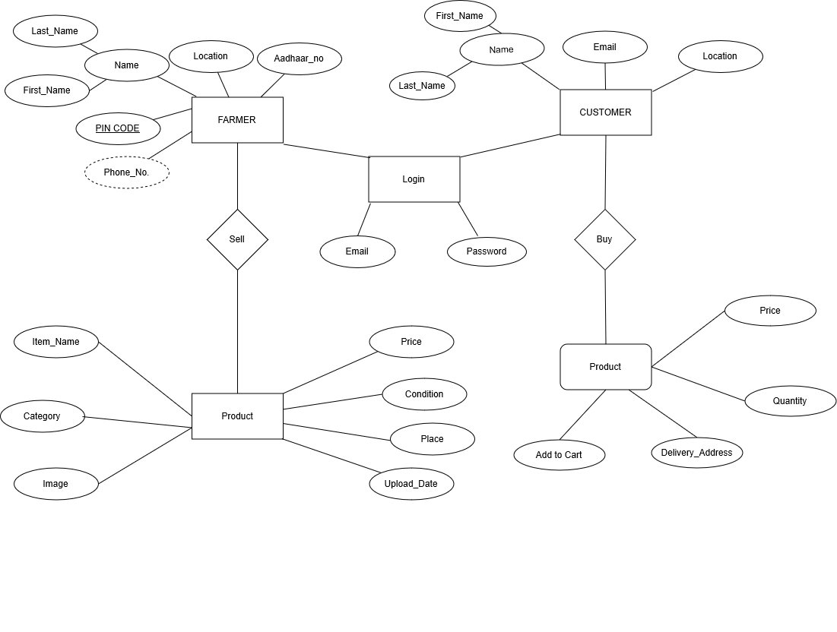

#### Fig 3.1-E R Diagram of FARM TO HOME

**Chapter 4**

**Detailed Design**

The design describes the relation between various modules and functions of the system. Data flow diagrams (DFD) identify the main components that would be developed for the product and their interfaces. A DFD basically illustrates how data is processed by a system or a software in terms of inputs and outputs. As its name indicates, its focus is on the flow of information, where data comes from, where it goes and how it gets stored. There are different levels at which data flow diagrams can be shown. Each level is a magnification of the entities on the previous level and shows a more detailed description of the modules on the previous level. The data flow up to two levels has been illustrated in this section.

#### DFD LEVEL-0

The whole farm to Home process is an agricultural management system which is a communication media between various consumers, farmers and consumers.

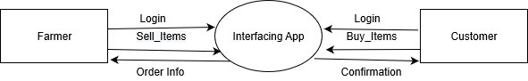

##### Fig 4.1-DFD level 0

* 1. **DFD LEVEL-1**

Request to purchase includes the requests made by the consumers for crops. In Request confirmation process farmers accept the requests for crop orders by consumers. Request purchase fertilizers includes the requests made by the farmers for fertilizers. In Request confirmation fertilizers consumers accept the requests for fertilizer orders by farmers.

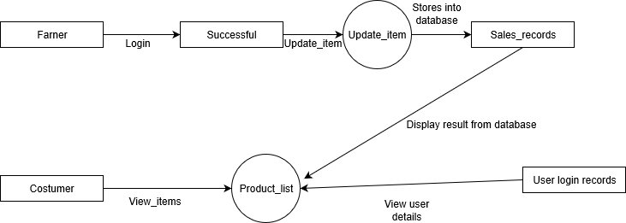

##### Fig 4.2-DFD level 1

* 1. **DFD Level-2 for crop order**

In Consumer Login consumers can login through consumer login. If they do not have an account they have to register first and then login. In Explore Crops consumers can explore all the types of crops uploaded by various farmers. In Order Crops consumer can order crops by first sending requests to the farmers. On confirmation from the farmer’s side the order will get placed.

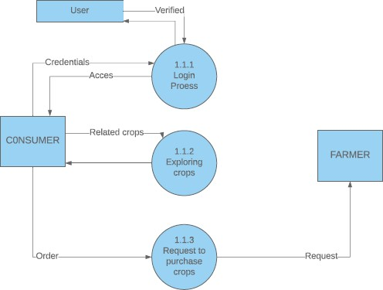

##### Fig 4.3-DFD level 2.1

* 1. **DFD Level-2 for Request Confirmation:**

In Farmer Login Farmers can login through farmer login. If they do not have an account they have to register first and then login. In Request confirmation process Farmers can accept/confirm the requests from various consumers. Once the farmer confirms the request the order gets placed.

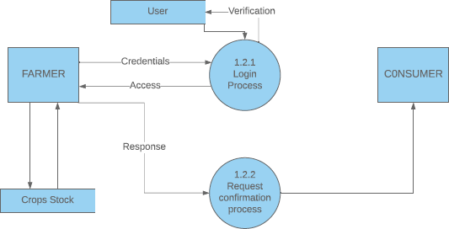

##### Fig 4.4-DFD level 2.2

* 1. **DFD Level-2 for Ordering of products:**

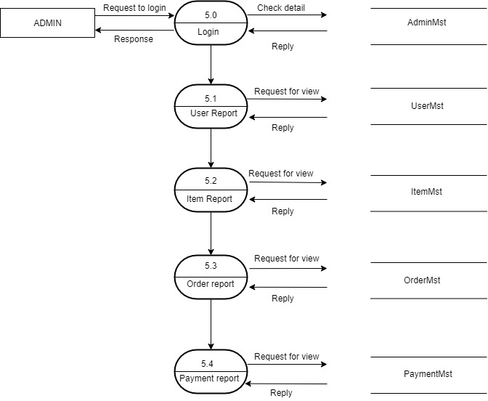In Farmer Login Farmers can login through Farmer login. If they do not have an account they have to register first and then login. In My orders, the consumer can order the products and can add the items to the cart and place the orders.

##### Fig 4.5-DFD level 2.3

* 1. **DFD Level-2 for Request Confirmation:**

Farmers and Consumers can login through login process. If they do not have an account they have to register first and then login. In Request confirmation process farmers can accept/confirm the requests from various farmers. Once the farmer confirms the request the order gets placed.

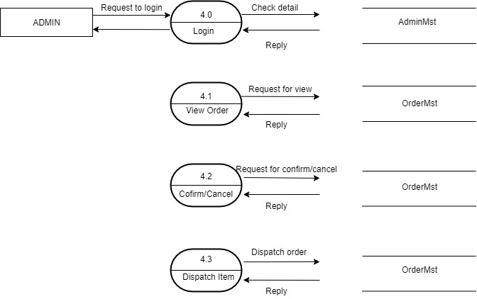

##### Fig 4.6-DFD level 2.4

**Chapter 5**

**Relational Schema and Normalization**

From the ER diagram, relational schemas are obtained by mapping entities and relationships to tables as shown in Fig 5.1. It is important to normalize the tables before implementing the database system in order to achieve an optimal design of the tables. Normalization consists of applying a sequence of tests to the relational schema to certify whether it satisfies a certain normal form. It is performed using a top-down approach by applying the criteria for each successive normal form to each relation and decomposing the relations as required. During normalization each relational schema is analyzed based on functional dependencies, resulting in a relation schema with minimal redundancy.

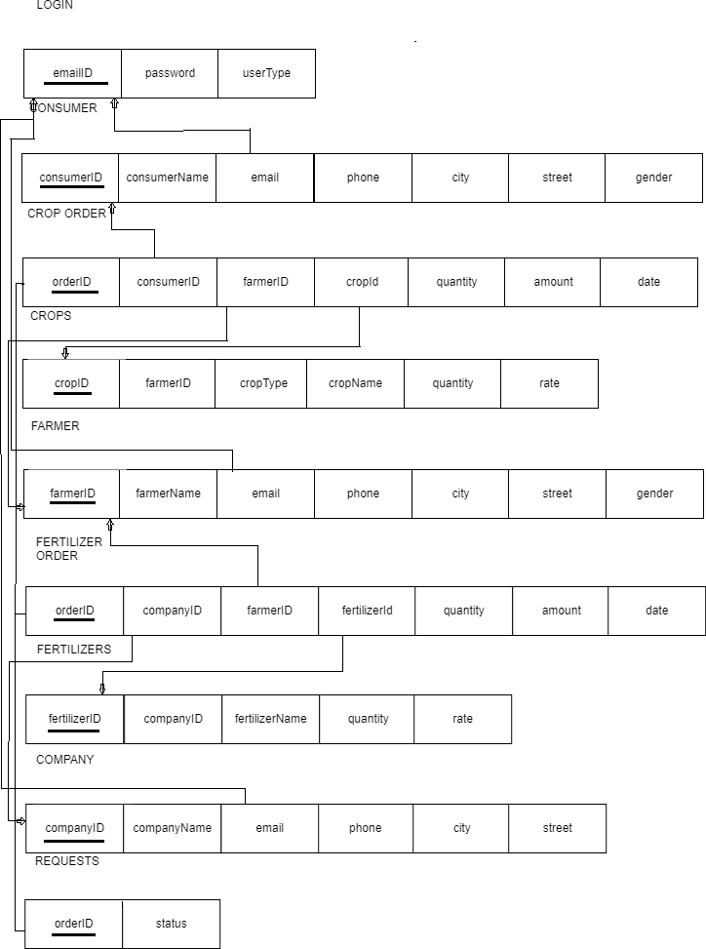

#### Fig5.1 -Relational Schema

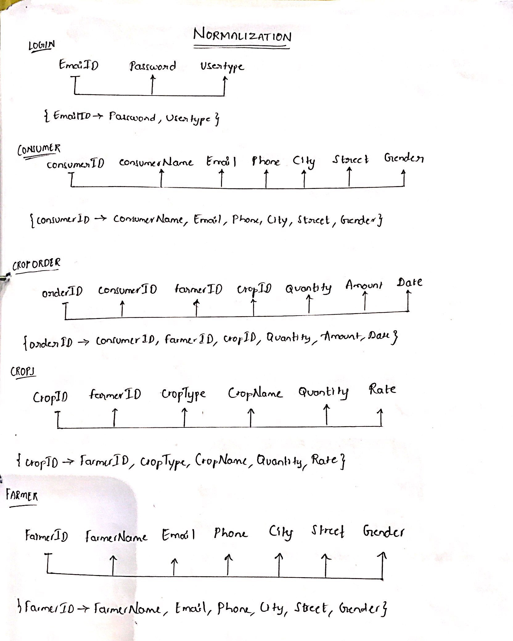

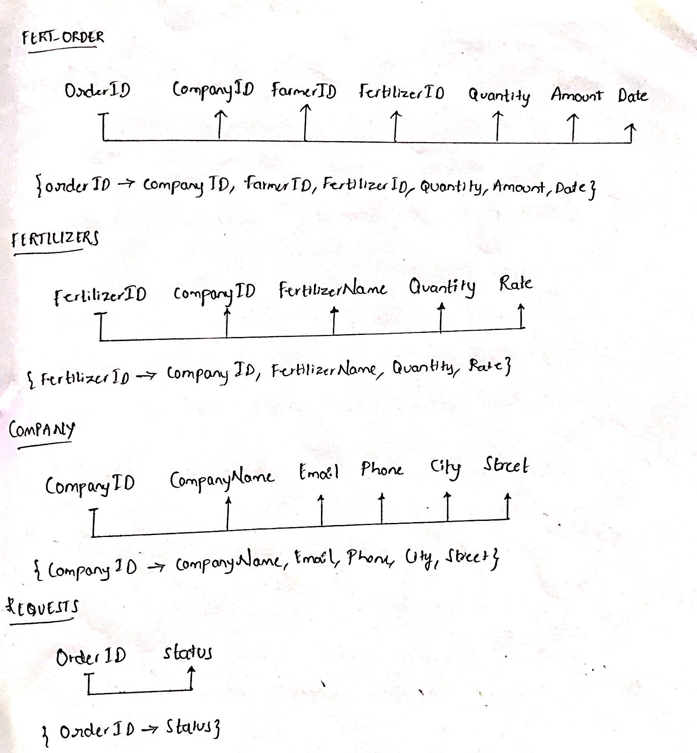

***Fig 5.2 Normalization to 1NF,2NF,3NF***

**Chapter 6**

**Integrating NoSQL to SQL Database**

We have used NOSQL for storing he feedback from various buyers of crops and fertilizers i.e. consumers and farmers. We have used two collections. In Crop Feedback collection the feedback given by the consumers on various crops they have ordered is stored. Once the order is placed and the consumer gets the crops delivered he/she gets an email . Once he/she receives the email he can give the feedback about the crops. In Fertilizer Feedback collection the feedback given by the farmers on various fertilizers they have ordered is stored. Once the order is placed and the farmer gets the fertilizers delivered he/she gets an email . Once he/she receives the email he can give the feedback about the fertilizers. Here the document is stored as shown below:

## Chapter 7

**Conclusion**

The Farm to Home was built using flask in python. The structured data was stored using MySQL and the unstructured using Xampp. The Consumer can log-in using his credentials to order crops. The Farmer after logging in can add crops to the database. The relational Schema has been reduced to 3rd Normal form, where multi valued attributes, composite attributes, partial and transitive dependencies have been removed.

Post the order the consumer has to wait for the confirmation of the order by the farmer followed by the further external transactions. The feedback form consists of the overall rating of the crop.

The same thing follows for the scene where the transaction happens between the farmer and consumer for the purchase of fertilizers. Thus, a complete working of the Farm to Home has been created and built to ensure an easy yet efficient experience for the customer to place his/her order. The project in overall focuses on reducing the burden of the farmer for selling the harvested crops, and also to overcome the involvement of the middlemen and curbing the farmer’s profit.

## References

1. <https://www.w3schools.com/sql/>
2. https://docs.Xampp.com/manual/tutorial/query-documents
3. Abraham Silberschatz, Henry F. Korth and S. Sudarshan, Database System Concepts, McGraw- Hill Education (Asia), Fifth Edition, 2006.
4. Kyle Banker, Xampp in Action, Manning Publications, Illustrated Edition, 2011
5. [https://www.tutorialspoint.com/Xampp/](https://www.tutorialspoint.com/mongodb/)
6. <http://flask.palletsprojects.com/en/1.1.x/>

## Appendix Screenshots:

**Fig A.1 Home Page** – Home page of the website displaying the introduction of the project.

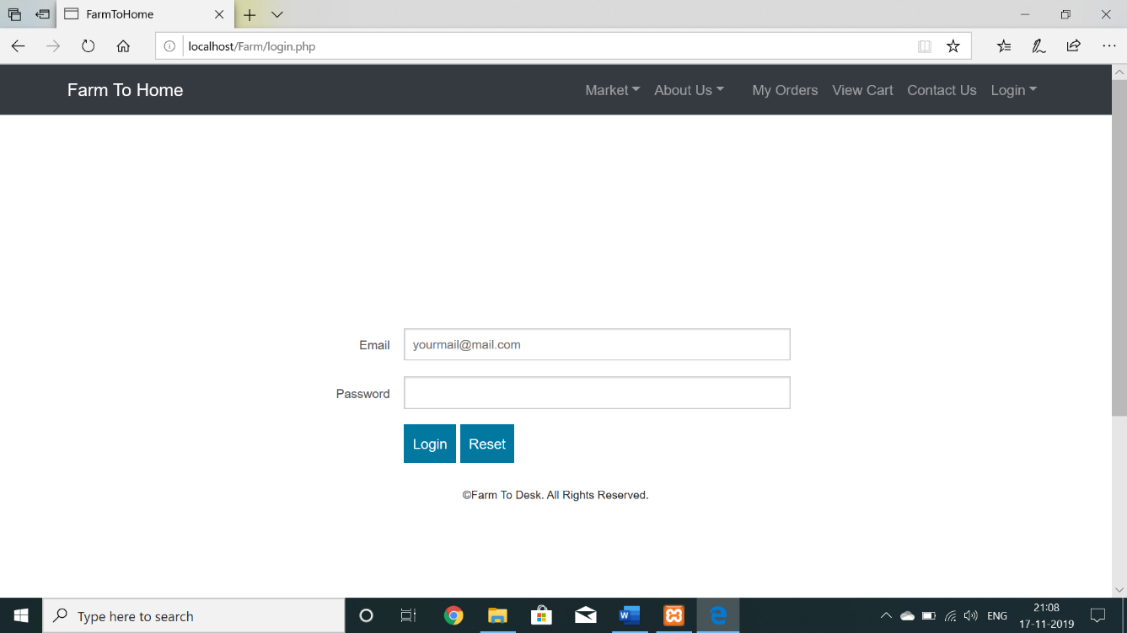

**Fig A.2 Login –** The users can login by providing verified email id and password.

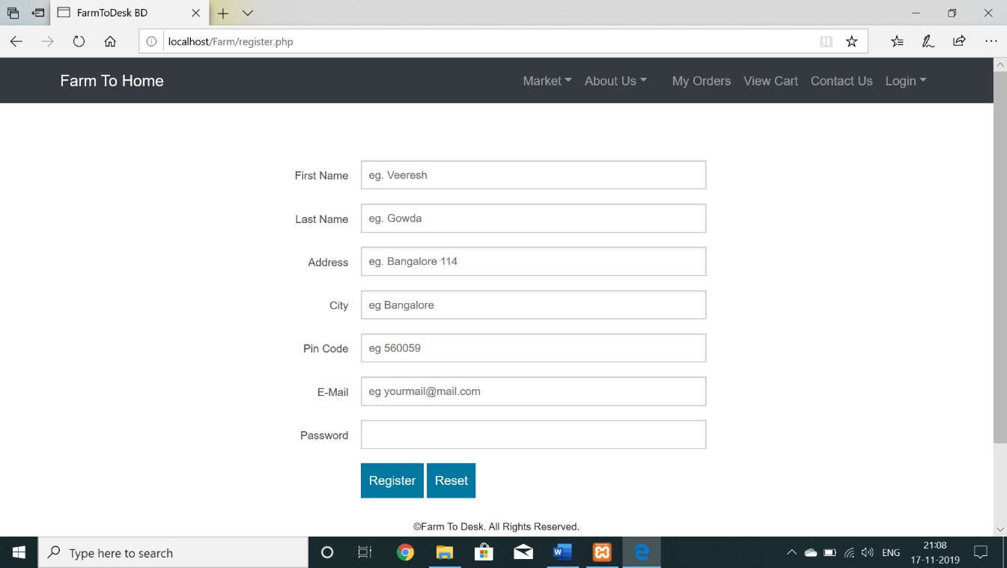

**Fig A.3 Register**: The new users can register by providing all the required details.

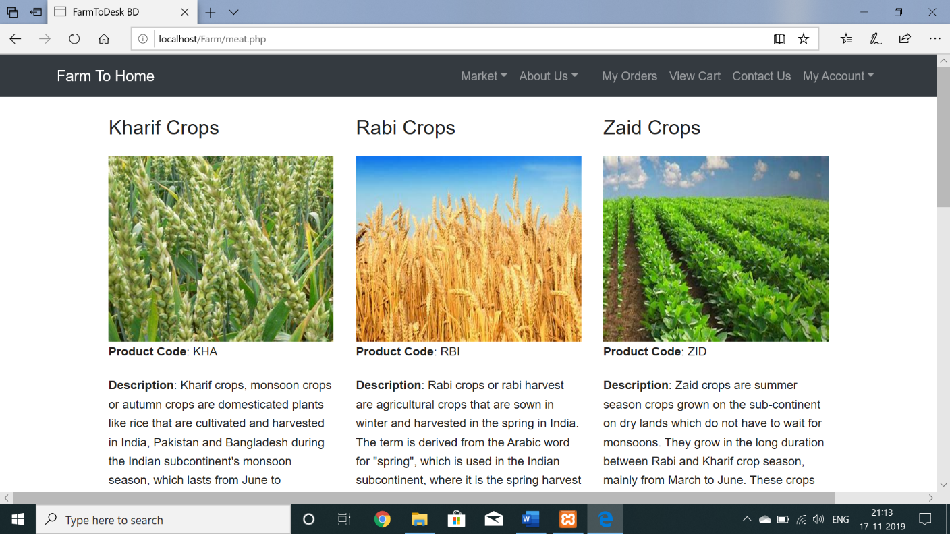

**Fig A.4 Crop Market-** This is the page where consumers order crops from various farmers.

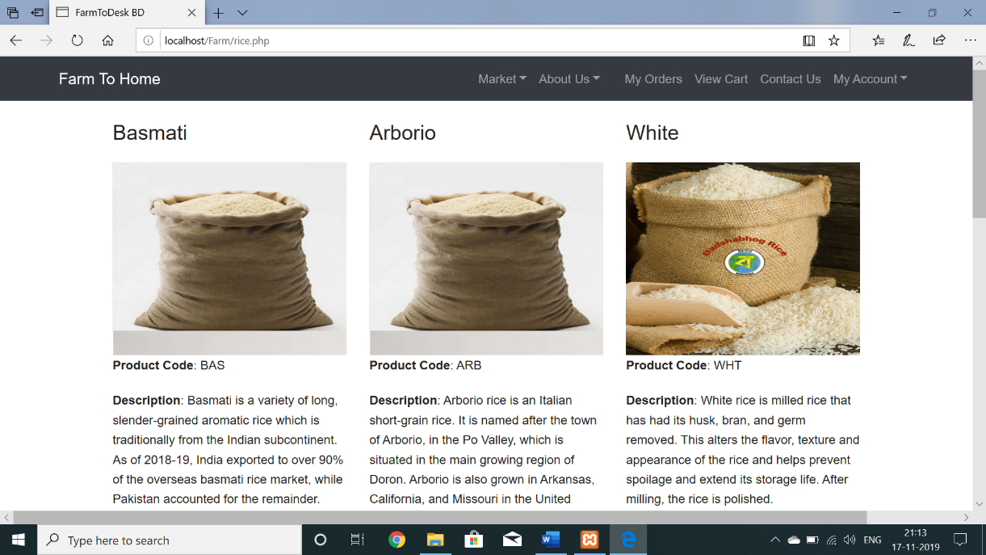

**Fig A.5 Rice Market**- This is the page wherein consumers can order grains form farmers.

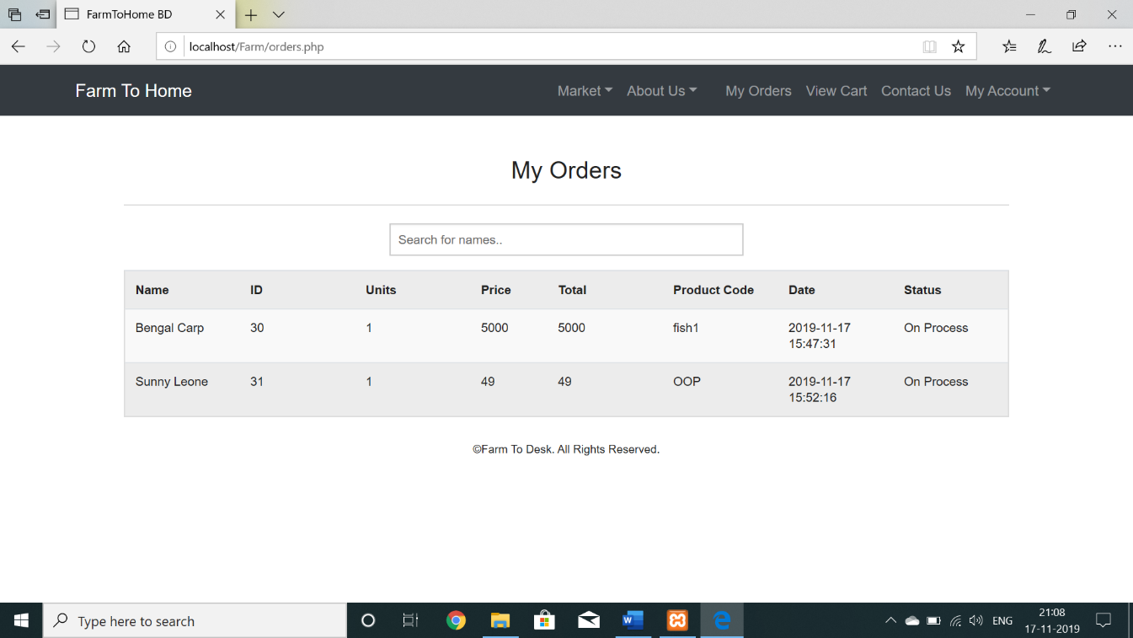

**Fig A.6 My Orders**: Page wherein the orders of consumers are displayed.

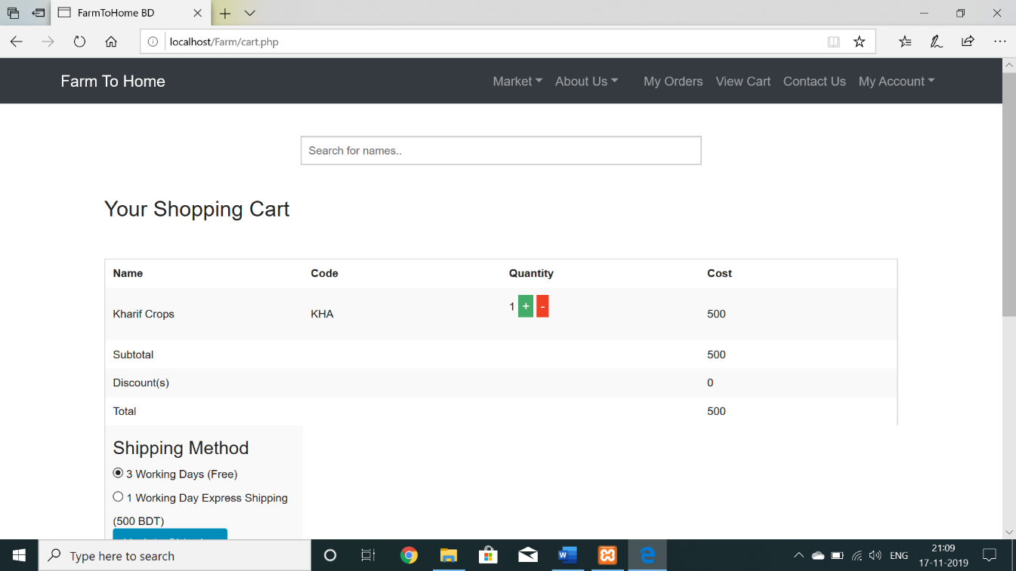

**Fig A.7 Cart**: Page displaying the shopping cart of an user.